Name: Shailja Kant Tiwari

Course: B.Sc(H) Physics, Sem 5

Roll No.-081

Part-1)Finding solution of s-wave Schrondinger solution in ground state and first excited state using E=_13.6eV

Source Code:

clc

clear

clf

e=3.795; m=0.511*10^6; h=1973

n=input("Enter n: ")

E=input("Enter E:")

r=linspace(0.01,10,n+1)

k=10/n

U(1,1)=1

U(n+1,n+1)=1

for i=2:n

V(i)=(-(e^2)/r(i))

A(i)=((2*m)/(h*h))*(V(i)-E)

U(i,i)=-(2+((k^2)*A(i)))

U(i,i-1)=1

U(i,i+1)=1

end

B=zeros(n+1,1)

B(1)=0.01

B(n+1)=0

u=U\B

a=gca()

a.x_location="origin"

a.y_location="origin"

plot(r',u)

xlabel('r','fontsize',3)

ylabel('u(r)','fontsize',3)

Output:

Enter n: 1500

Enter E:-13.6

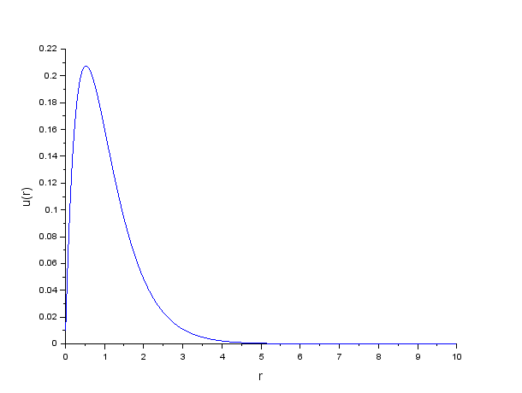

Enter n: 1500

Enter E:-3.4

